Rounded Images
You can use the border-radius property to create rounded images:
img {
border-radius: 8px;
}

img {
border-radius: 50%;
}

Thumbnail Images
Use the border property to create thumbnail images:
img {
border: 1px solid #ddd;
border-radius: 4px;
padding: 5px;
width: 150px;
}

The CSS display Property
The display property is an important CSS property for controlling layout. It specifies whether an HTML element is treated as a block or an inline element.
Every HTML element has a default display value, depending on what type of element it is. The default display value for most elements is block or inline.
The display property is used to change the default display behavior of HTML elements.

Block-level Elements
A block-level element ALWAYS starts on a new line and takes up the full width available (stretches out to the left and right as far as it can).
The <div> element is a block-level element.
Examples of block-level elements:
- <div>
- <h1> - <h6>
- <p>
- <form>
- <header>
- <footer>
- <section>

Inline Elements
An inline element DOES NOT start on a new line and only takes up as much width as necessary.
This is an inline <span> element inside a paragraph.
Examples of inline elements:
- <span>
- <a>
- <img>

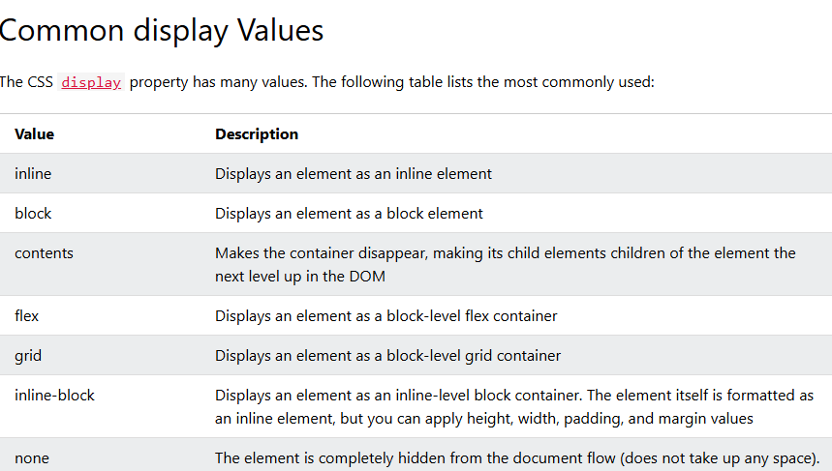

Override the Default Display Value
The display property is used to change the default display behavior of HTML elements.
Changing an inline element to a block element, or vice versa, can be useful for making the page look a specific way, and still follow the web standards.
A common example is to change <li> elements to inline, to create a horizontal menu:
<!DOCTYPE html>
<html>
<head>
<style>
ul {
list-style-type: none;
margin: 0;
padding: 0;
}

li {
display: inline;
}
</style>
</head>
<body>

<p>Display a list of links as a horizontal menu:</p>

<ul>
<li><a href="#home">Home</a></li>
<li><a href="#news">News</a></li>
<li><a href="#contact">Contact</a></li>
<li><a href="#about">About</a></li>
</ul>

</body>
</html>

Display:block
<!DOCTYPE html>
<html>
<head>
<style>
span {
display: block;
}
</style>
</head>
<body>

<h1>Display span elements as block elements</h1>

<span>A display property with</span> <span>a value of "block" results in</span> <span>a line break between each span elements.</span>

</body>
</html>

<!DOCTYPE html>
<html>
<head>
<style>
a {
display: block;
}
</style>
</head>
<body>

<h1>Display links as block elements</h1>

<a href="/html/default.asp" target="_blank">HTML</a>
<a href="/css/default.asp" target="_blank">CSS</a>
<a href="/js/default.asp" target="_blank">JavaScript</a>

</body>
</html>

<!DOCTYPE html>
<html>
<head>
<style>
p {
background-color: blue;
padding: 10px;
}

span {
background-color: red;
color: white;
padding: 10px;
}

p.ex1 {display: none;}
p.ex2 {display: inline;}
p.ex3 {display: block;}
p.ex4 {display: inline-block;}
p.ex5 {display: flex;}
p.ex6 {display: grid;}
</style>
</head>
<body>
<h1>The display Property</h1>

<h2>display: none:</h2>
<p class="ex1">
<span>Text 1</span>
<span>Text 2</span>
<span>Text 3</span>
</p>

<h2>display: inline:</h2>
<p class="ex2">
<span>Text 1</span>
<span>Text 2</span>
<span>Text 3</span>
</p>

<h2>display: block:</h2>
<p class="ex3">
<span>Text 1</span>
<span>Text 2</span>
<span>Text 3</span>
</p>

<h2>display: inline-block:</h2>
<p class="ex4">
<span>Text 1</span>
<span>Text 2</span>
<span>Text 3</span>
</p>

<h2>display: flex:</h2>
<p class="ex5">
<span>Text 1</span>
<span>Text 2</span>
<span>Text 3</span>
</p>

<h2>display: grid:</h2>
<p class="ex6">
<span>Text 1</span>
<span>Text 2</span>
<span>Text 3</span>
</p>

</body>
</html>

Text-align:
<!DOCTYPE html>
<html>
<head>
<style>
h1 {
text-align: center;
}

h2 {
text-align: left;
}

h3 {
text-align: right;
}
</style>
</head>
<body>

<h1>Heading 1 (center)</h1>
<h2>Heading 2 (left)</h2>
<h3>Heading 3 (right)</h3>

<p>The three headings above are aligned center, left and right.</p>

</body>
</html>

Example text-align: justify

<!DOCTYPE html>
<html>
<head>
<style>
div {
border: 1px solid black;
padding: 10px;
width: 200px;
height: 200px;
text-align: justify;
}
</style>
</head>
<body>

<h1>Example text-align: justify</h1>

<p>The text-align: justify; value stretches the lines so that each line has equal width (like in newspapers and magazines).</p>

<div>
In my younger and more vulnerable years my father gave me some advice that I've been turning over in my mind ever since. 'Whenever you feel like criticizing anyone,' he told me, 'just remember that all the people in this world haven't had the advantages that you've had.'
</div>

</body>
</html>

Text-align-last example

<!DOCTYPE html>
<html>
<head>
<style>
p.a {
text-align-last: right;
}

p.b {
text-align-last: center;
}

p.c {
text-align-last: justify;
}
</style>
</head>
<body>

<h1>The text-align-last Property</h1>

<h2>text-align-last: right:</h2>
<p class="a">Lorem ipsum dolor sit amet, consectetur adipiscing elit. Etiam semper diam at erat pulvinar, at pulvinar felis blandit. Vestibulum volutpat tellus diam, consequat gravida libero rhoncus ut.</p>

<h2>text-align-last: center:</h2>
<p class="b">Lorem ipsum dolor sit amet, consectetur adipiscing elit. Etiam semper diam at erat pulvinar, at pulvinar felis blandit. Vestibulum volutpat tellus diam, consequat gravida libero rhoncus ut.</p>

<h2>text-align-last: justify:</h2>
<p class="c">Lorem ipsum dolor sit amet, consectetur adipiscing elit. Etiam semper diam at erat pulvinar, at pulvinar felis blandit. Vestibulum volutpat tellus diam, consequat gravida libero rhoncus ut.</p>

</body>
</html>

